G-Analysis
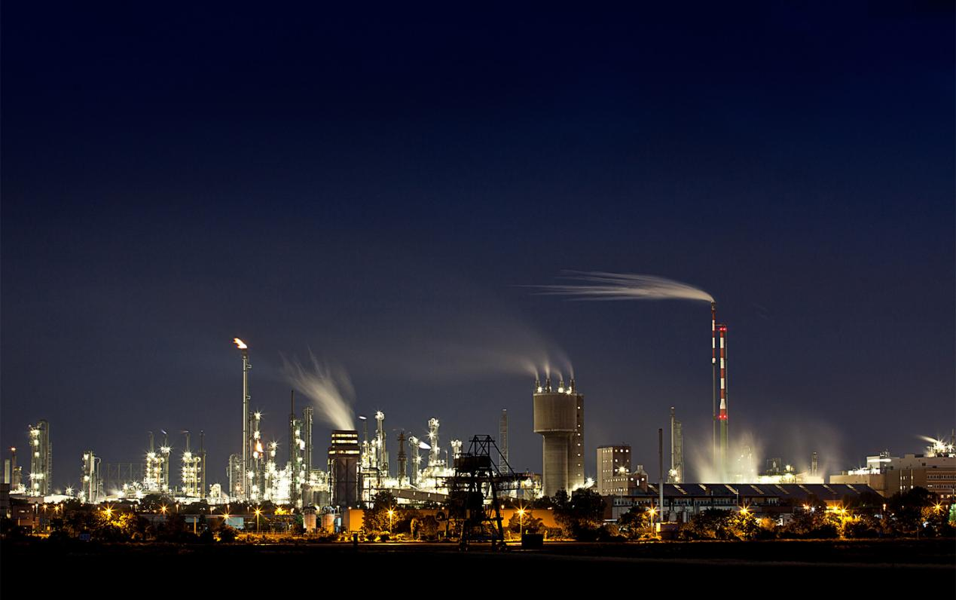

Dashboard Module Overview 1
Diagram, Tabelle, and Wert Tabs 6
Diagramm (Diagram) Tab 7
Tabelle (Table) Tab 8
Wert (charts) Tab 9
Steps to Create a Graph Tile on the Dashboard 9
Steps to Create a Table Tile on the Dashboard 12
Tile Design and Customization 15
Information Display 15
Refresh and Update Mechanism 16
User Preferences and Settings 16
Save tiles structure tab 16
Messstellen, Zeitvergleich, and Kennzahlen Tabs 17
Messstellen (Measuring Points) Tab 17
Zeitvergleich (Time Comparison) Tab 18
Kennzahlen (Key Figures) Tab 18
Manuell Data Tab 19
Manuell 15min Data Tab 19
Third-Party Providers and Software Libraries 20
Dashboard Module Overview
The G-Analysis Dashboard provides a centralized interface to monitor, analyze, and visualize energy data from different measurement points (Messstellen). The dashboard allows users to view graphical data, tables, and comparisons.
The Dashboard Portal is designed to give users a quick and comprehensive overview of key information through customizable tiles. It displays saved graphs and tables in different formats for easy data visualization and analysis. The dashboard provides multiple visualization options that allow users to analyze energy and measurement data in different formats.
The Diagramm, Tabelle, and Wert modules help users interpret data through charts, tables, and key indicators.
The Auswertung hinzufügen module allows users to create and add new tiles to the dashboard.
The Struktur speichern function allows users to save the current layout and configuration of the dashboard.
The Messstellen, Zeitvergleich, and Kennzahlen tabs display lists of saved graphs and tables created by the user in different analysis categories. These tabs allow users to quickly access previously created visualizations and analyses without needing to recreate them.
The Manuell Data and Manuell 15min Data tabs display lists of manually imported data submitted by the user.
Here's a detailed breakdown of its features and functionalities:
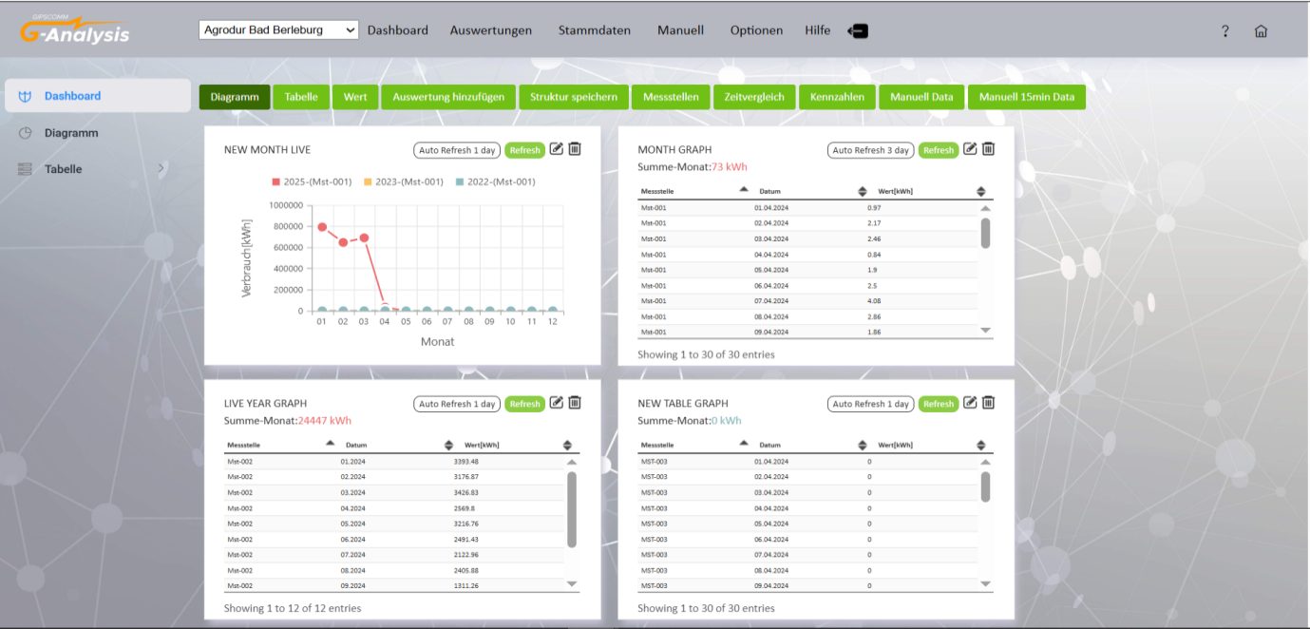
Top Navigation Menu and Mandant Selector
The G-Analysis application features a horizontal top navigation bar that provides access to all major modules:
- Mandant (Tenant): A dropdown selector at the top-left allows users to switch between different tenant databases. This is critical for multi-tenant deployments where each organization has its own isolated data.
- Dashboard: Returns to the main dashboard view.
- Auswertungen (Evaluations): Contains Berichte (ISO reports: SpaEfV Tabelle 1 & 2), Diagramme (Messstellenvergleich, Zeitvergleich, Kennzahlendarstellung), Verbrauchsdatenexport, and Produktion.
- Stammdaten (Master Data): Access to Rechteverwaltung (Admin Portal), Unternehmensstruktur (Mandanten, Organisationen, Liegenschaften, Vers.Bereiche, Messstellen-E/B, Standorte, Standortdaten 3.), Anlagenverwaltung, Messmittelverwaltung, Produkteverwaltung, Kennzahlen/Alarme, and Editor (Berechnungsformeln, Vorlagenformeln).
- Manuell (Manual): In.Messwerte (Interne Betriebsdaten, Interne Energiedaten, Energie Rückschritt, Energerize/Measuring), Ex.Rechnungen (Rechnungen, Rechnungsvergleich), Import Manuell Data, Import 15min Data.
- Optionen (Options): Basisdaten (Energieträger, Energieformen, Zählpunktnummern, Erweiterungen, Gruppierung Diagramme), Schichtdaten.
- Hilfe (Help): Links to help documentation (e.g., PDF).
- Logout: Ends the user session.
Energy Regression (Energie Rückschritt)
The Energy Regression module is accessible via Manuell > In.Messwerte > Energie Rückschritt. It allows users to perform statistical regression analysis on energy consumption data:
- Excel Upload: Users can upload an Excel file containing energy and influencing variable data (e.g., Jahr, Monat, production volume).
- Data Configuration: The input table displays columns for year (Jahr), month (Monat), and user-defined variables. Users can add or remove columns as needed.
- Calculate Regression: The "Berechnung durchführen" (Calculate) button runs the regression analysis. Results include regression coefficients, R², and other statistical metrics.
- Export: Users can export regression results for further use.
Production Module (Produktion)
Accessible via Auswertungen > Produktion. The Production module provides machine-level and production data analysis:
- Machine Table Configurations: Configure which columns to display (e.g., Anlage, Auftragsmenge, Bestellung, Artikel, Gutmenge, Programm, Zeit_zyklus, Fertigst. Auftrag[h], Werkzeug, Kavitäten, Letzte_störung, Bisher_produziert). Supports dynamic columns.
- Energy Charts: Visualize energy data with time intervals, graph types (Line, Bar), and period selection (Year, Month, Custom).
- Production Charts: Analyze production data with similar configuration options.
- Mixed Charts: Combine energy and production data in a single chart.
- KPI Charts: Display key performance indicators for machines with configurable "letzte x Aufträge" (last x orders).
Energerize/Measuring
Accessible via Manuell > In.Messwerte > Energerize/Measuring. This module integrates with the Energerize measuring system for importing and managing measurement data. It displays imported data and provides options for data management and historie (history) viewing.
Stammdaten (Master Data)
The Stammdaten menu provides comprehensive data management for organizational structure and configuration:
- Rechteverwaltung: Admin Portal link for user/role management.
- Unternehmensstruktur: Mandanten (tenants), Organisationen, Liegenschaften (properties), Vers.Bereiche (supply areas), Messstellen-E/B (energy/operational measurement points), Standorte, Standortdaten 3.
- Anlagenverwaltung: Anlagen (equipment), Energieversorgung, Dokumente, Historie, Channel.
- Messmittelverwaltung: Physical measurement devices and their configuration.
- Produkteverwaltung: Products, weitere Konfiguration, Historie.
- Kennzahlen/Alarme: Key figures (Kennzahlen) and alarms (Alarme) with formulas and threshold configuration.
- Editor: Berechnungsformeln (calculation formulas) and Vorlagenformeln (template formulas) for defining virtual measurement points and KPIs.
Rechnungen (Invoices)
Accessible via Manuell > Ex.Rechnungen:
- Rechnungen: Enter and manage external energy invoices. Fields include Messstelle, Energieträger, Rechn. Nr, Zählpunkt Nr, Rechn. Datum, vom/bis, Versorger, Einheit, Menge, Verbrauch[kWh], Kosten[€], HT/NT split, and detailed cost components (EEG-Umlage, KWK-Umlage, §19 NEV-Umlage, etc.).
- Rechnungsvergleich: Compare invoice data across different periods or measurement points.

SpaEfV Tables
Accessible via Auswertungen > Berichte > ISO:
- SpaEfV Tabelle 1: Energy consumption report by Energieträger (energy carriers) or Einspeisepunkten (feed-in points). Supports Basis Version, Benutzerdefinierte Version, and Bezugsbereich (reference scope: Gesamtes Unternehmen, Bestimmte Organisation, Bestimmte Liegenschaft).
- SpaEfV Tabelle 2: Energy consumption report by Hauptverbraucher (main consumers), Nebenverbraucher (auxiliary consumers), or Einzelverbrauchern (individual consumers). Similar scope and version options as Tabelle 1.

Verbrauchsdatenexport (Consumption Data Export)
Accessible via Auswertungen > Verbrauchsdatenexport. Allows users to export energy consumption data:
- Select Messstelle (measurement point), Jahr (year), and Monat (month).
- Click "Daten abfragen" to retrieve data.
- Output table displays: Messstelle, Datum/Zeit, Phase, Wert. Data can be exported for external analysis.

Berechnungsformeln and Vorlagenformeln (Formula Editors)
Accessible via Stammdaten > Editor:
- Berechnungsformeln: Define calculation logic for virtual measurement points and KPIs. Supports Formelmodus, Bezug (Messstelle, Anlage, Produkt), and references to Korrekturfaktoren, BDE-Schichtdaten, Produktstammdaten, Anlagen, and Messstellen.
- Vorlagenformeln: Create reusable formula templates with Bezeichnung, Notiz, and parameter mappings (Anlage, Messstelle, Formel, Produkt_Par-VE, Produkt_Par-RohInput).

Admin Portal
Accessible via Stammdaten > Rechteverwaltung > Admin Portal. Opens in a new tab/window. Used for centralized user and permission management across tenants, including Betreuergruppen (supervisor groups), Mandantengruppen, Admins, and Benutzer.
Import Manuell Data and Import 15min Data Pages
- Import Manuell Data: Dedicated page (import-manuell-data.html) for bulk manual data import. Users can upload or enter data for energy and operational measurements.
- Import 15min Data: Dedicated page (import-manuell-15min-data.html) for importing data in 15-minute intervals. Supports granular time-based data entry for high-resolution analysis.
Diagram, Tabelle, and Wert Tabs
The Diagramm, Tabelle, and Wert tabs are used to filter and display tiles based on their specific data formats, allowing users to view information in the form of charts, tables, or key value indicators.
These tabs help the user easily navigate and focus on specific types of data presentations within the dashboard.
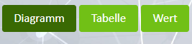
Diagramm (Diagram) Tab: User clicks on the “Diagramm” tab, the dashboard displays data in a graphical visualization format, such as line graphs and bar graphs, to help users easily analyze trends, comparisons, and patterns in energy consumption or measurement data.
The dashboard shows tiles containing different types of graphical charts that represent the selected data. These visualizations help users quickly understand data behaviour and compare values across different measurement points or time periods.
Features: -
- Displays visual charts such as line graphs, bar graphs, or other graphical representations.
- Helps users quickly understand energy consumption trends over time.
- Supports comparison between different measurement points (Messstellen) or different time periods.
- Each chart is displayed inside a dashboard tile, which can be refreshed, edited, or deleted.
- Users can configure charts by selecting specific measurement points, time ranges, and parameters.
- Provides an easy and interactive way to monitor and analyze energy data visually.
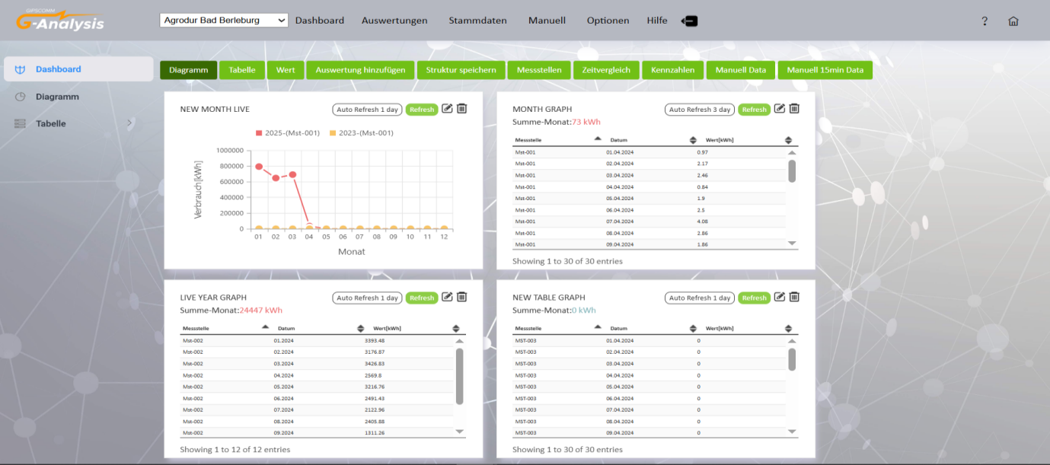
Tabelle (Table) Tab: User clicks on the “Tabelle” tab, the dashboard is filtered to display only tiles containing data in table format, allowing for a structured and detailed view of the information.
When a user clicks on the “Tabelle” tab, the dashboard automatically filters and displays only the tiles that contain data in table format. This helps users focus on numerical data rather than graphical visualizations.
Each table tile presents information in rows and columns, making it easier to review, compare, and analyze specific values from different measurement points or datasets.
Features: -
- Displays data in a clear tabular structure with rows and columns.
- Shows detailed information such as measurement point (Messstelle), date (Datum), and measured values (Wert).
- Helps users analyze exact numerical values rather than graphical trends.
- Each table is displayed inside a dashboard tile with options to refresh, edit, or delete the tile.
- Supports viewing multiple table tiles simultaneously for different datasets or analyses.
- Enables users to easily review and compare structured data across different records.
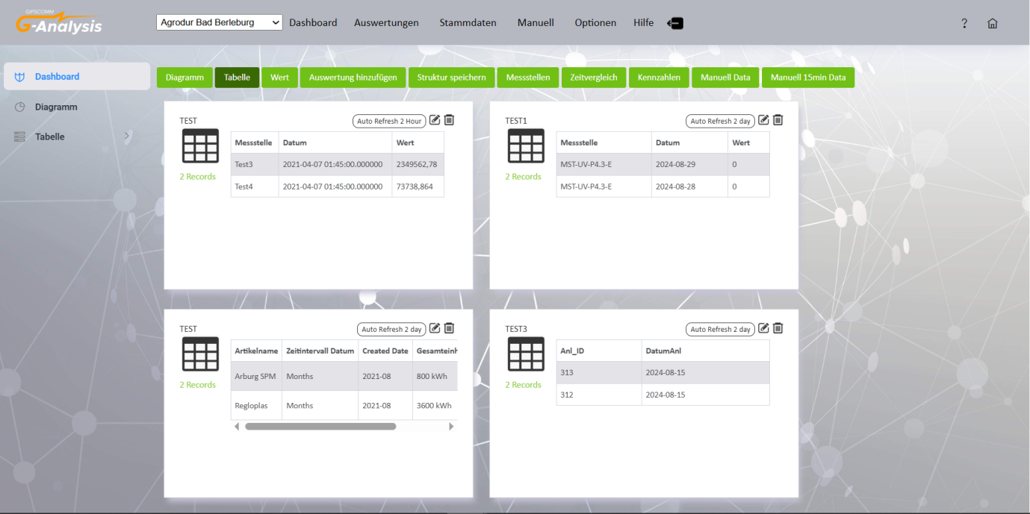
Wert (charts) Tab: User click on “Wert” tab, displays tiles that present numerical values and key indicators in a visual chart format. This tab is used to highlight important calculated values or summarized data for quick monitoring and analysis.
When a user clicks on the “Wert” tab, the dashboard filters and displays only the tiles that contain value-based visualizations or KPI charts.
Features: -
- Displays value-based charts or KPI visualizations in dashboard tiles.
- Highlights important numerical values and calculated metrics.
- Allows users to quickly monitor key energy performance indicators.
- Each tile is associated with specific measurement points (Messstellen).
- Users can edit, update, or delete tiles directly from the dashboard.
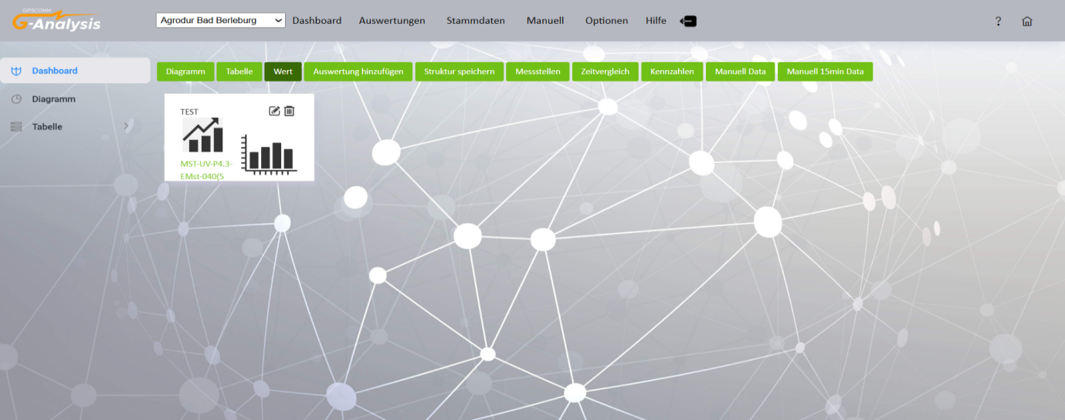
Steps to Create a Graph Tile on the Dashboard
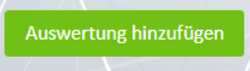
- Access the Dashboard Module:
- Open the dashboard module where you want to add the new graph tile.
- Click 'Auswertung hinzufügen':
- Locate and click on the "Auswertung hinzufügen" button. This will open a dialog for adding a new analytical element to your dashboard.

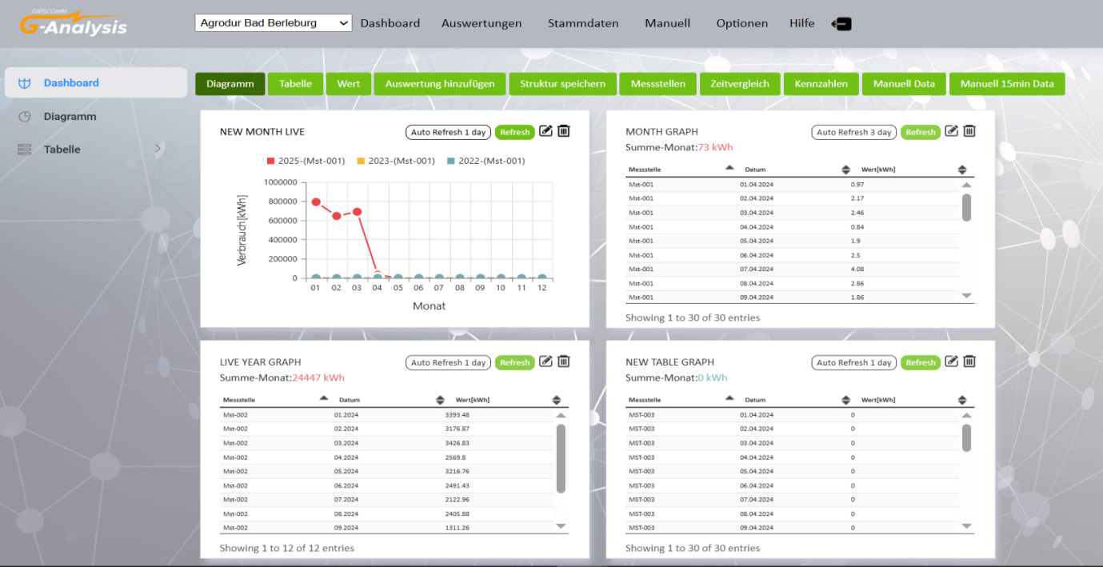

- Insert Name and Type of Graph:
- In the dialog that appears:
- Enter the name of the graph in the provided field. This name will help you identify the graph tile on your dashboard.
- Art des Datensatzes (Dataset Type): - This dropdown allows the user to select the type of dataset for the dashboard tile such as Messstellen-Energie, Alarm-Info Board, Messstellen-Betrieb, Graph.
- Select the type of graph you want to create (e.g., line chart, bar chart, pie chart).

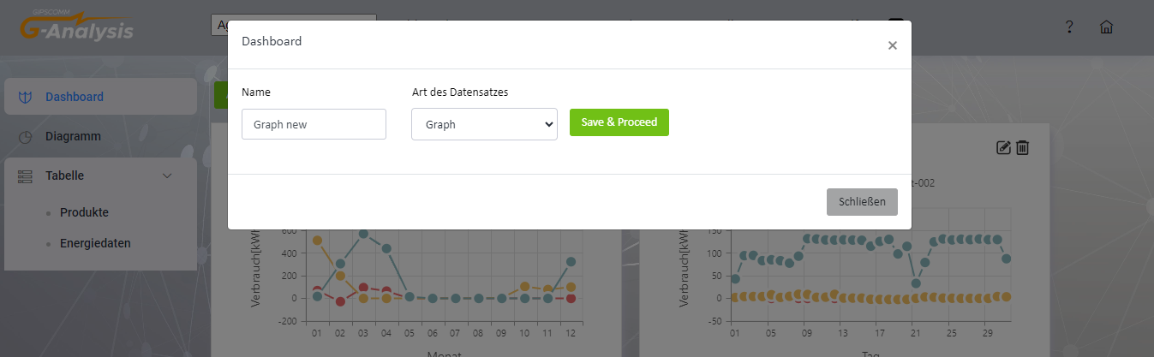

- Click 'Save & Proceed':
- After specifying the graph name and type, click "Save & Proceed" to proceed to the next step.
- Add Dimensions and Specify Graph Type:
- Specify the dimensions of the tile. Ensure the dimensions are greater than 2x2 to provide adequate space for the graph.
- Choose the graph type from the available options, either "Table" or "Graph", depending on your data presentation preference.

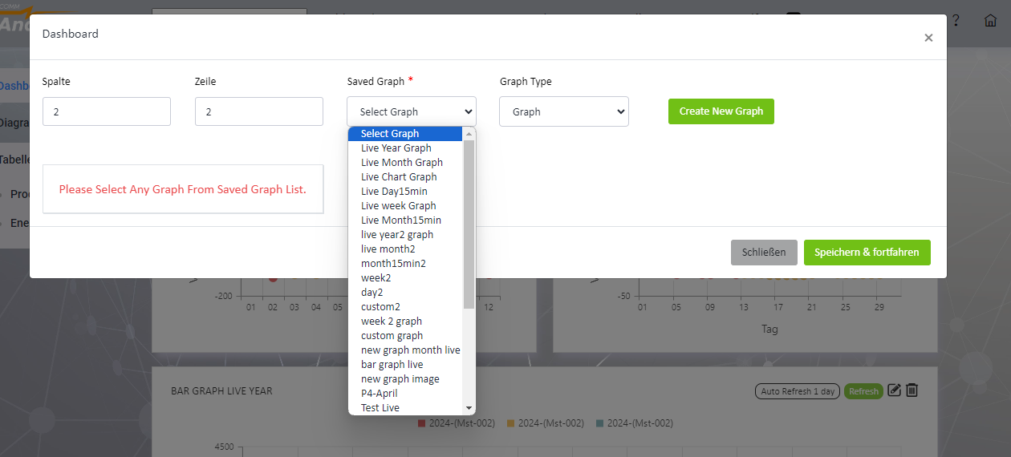

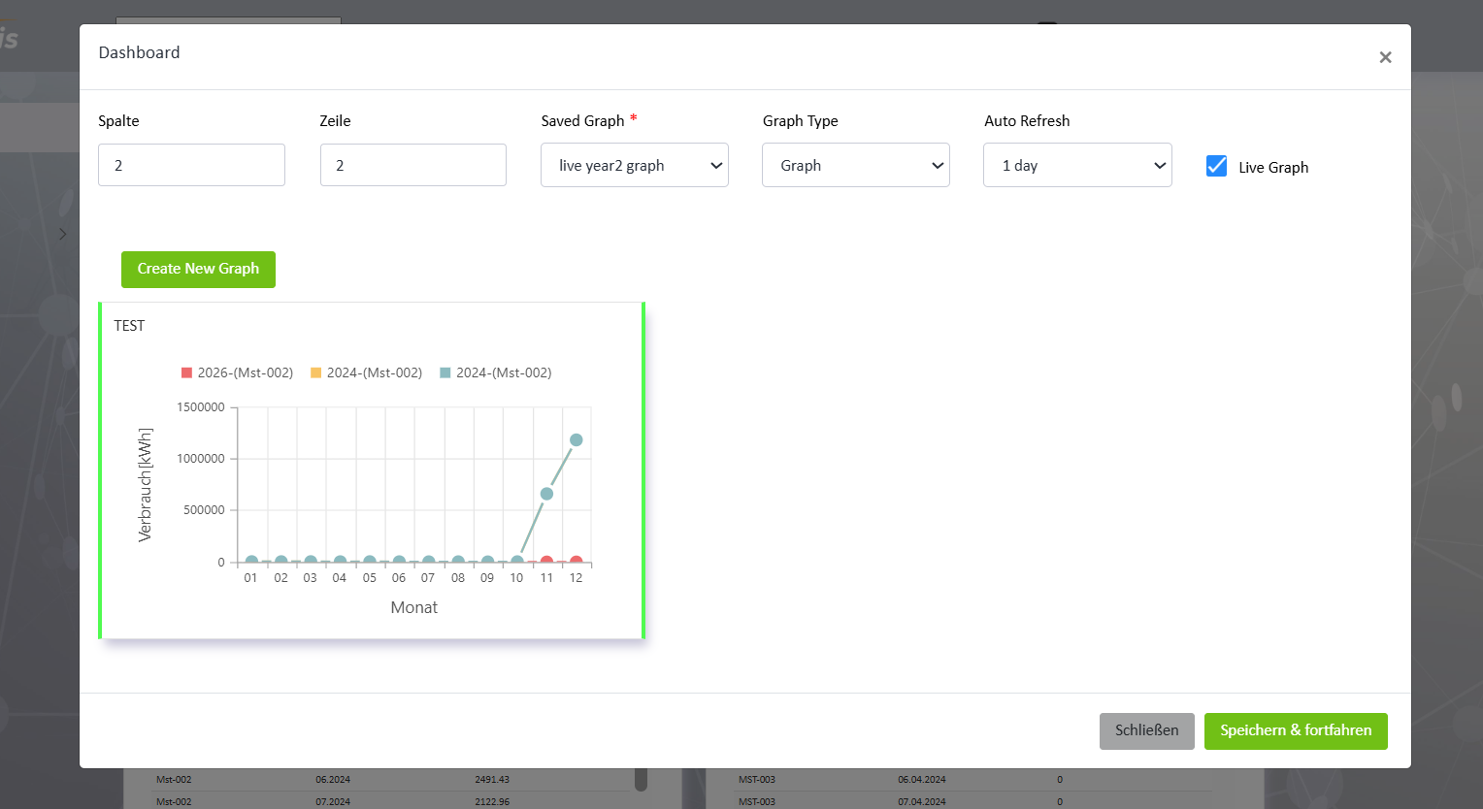
- Click 'Save' (Speichern & fortfahren):
- Once you have configured the dimensions and selected the graph type, click the "Save" button to add the new tile to your dashboard.
- View the New Tile:
- The newly created tile should now be displayed on your dashboard, showing the graph or table as per your configuration.

Steps to Create a Table on the Dashboard

- Access the Dashboard Module:
- Open the dashboard module where you want to add the new Table tile.
2. Click 'Auswertung hinzufügen':
- Locate and click on the "Auswertung hinzufügen" button. This will open a dialog for adding a new analytical element to your dashboard.



3. Insert Name and Type of Graph:
- In the dialog that appears:
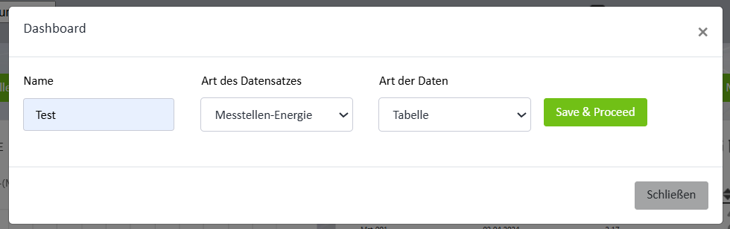
- Enter the name of the Table in the provided field. This name will help you identify the table tile on your dashboard.
- Art des Datensatzes (Dataset Type):- This dropdown allows the user to select the type of dataset for the dashboard tile such as Messstellen-Energie, Alarm-Info Board, Messstellen-Betrieb, Graph.
- Art der Daten (Data Type):- This dropdown defines how the selected dataset will be displayed on the dashboard.such as Tabell, Diagramm, Wert.
- Click 'Save & Proceed':
- After specifying the table name and type, click "Save & Proceed" to proceed to the next step.
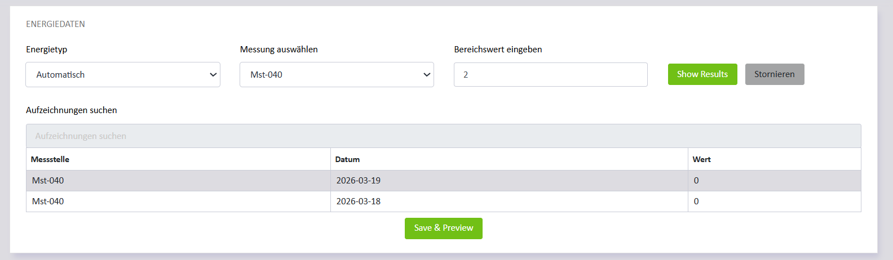
- Energietyp (Energy Type): - The Energietyp dropdown allows users to select the type of energy data to analyze.
- Messung auswählen (Select Measurement): - This dropdown allows users to select a specific measurement point (Messstelle) from which the energy data will be retrieved.
- Bereichswert eingeben (Enter Range Value): -This field allows the user to enter a range value or number of records that should be included in the analysis or displayed in the results.
- Show Results: - The Show Results button retrieves and displays the available data based on the selected filters.
- Save & Preview: - The Save & Preview button allows users to save the selected configuration and preview the resulting tile.
- Add Dimensions and Specify Table Type:
- Specify the dimensions of the tile. Ensure the dimensions are greater than 2x2 to provide adequate space for the table.
- Spalte (Column): - The Spalte field defines the column position or width of the tile on the dashboard grid layout. Users can adjust this value to control how much horizontal space the tile occupies.
- Zeile (Row): - The Zeile field specifies the row position of the tile within the dashboard layout. This helps organize tiles vertically on the dashboard.
- Auto Refresh: - The Auto Refresh dropdown allows users to define how often the tile data should automatically refresh.
- Erweiterte Ansicht anwenden (Apply Advanced View): - When enabled, this option displays the tile using an enhanced or expanded view, providing a clearer and more detailed presentation of the data.
- Kachelstruktur anpassen (Adjust Tile Structure): - This option allows users to manually adjust the tile layout or structure within the dashboard grid.

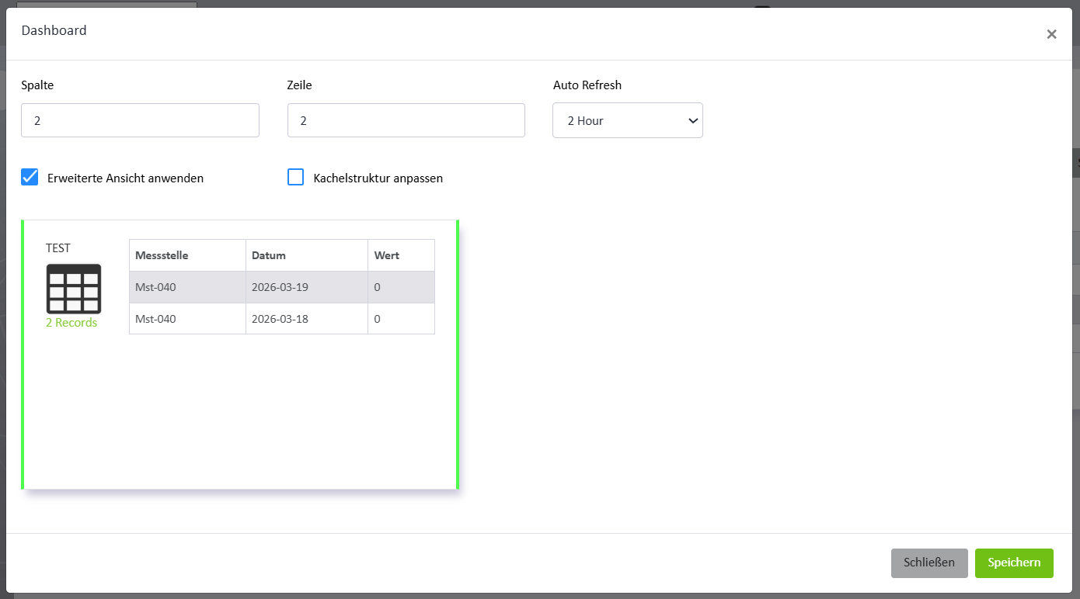
- Click 'Save' (Speichern):
- Once you have configured the dimensions and selected the table type, click the "Save" button to add the new tile to your dashboard.
- View the New Tile:
The newly created tile should now be displayed on your dashboard, showing the table as per your configuration.
Tile Design and Customization
- Graphical and Tabular Representation: Users can design tiles that display various types of information, including graphs, charts, and tables. This allows for a diverse presentation of data, catering to different analytical needs.
- Dynamic Data Display: Tiles can be configured to show real-time or periodically updated data. This ensures that the information presented is always current and relevant.
- Customizable Layout: Users have the flexibility to arrange and resize tiles according to their preferences, enabling a personalized and efficient dashboard layout.
Information Display
- Various Information Types: Each tile can be tailored to present different kinds of data, whether it’s quantitative figures, statistical graphs, or detailed tables. This provides a comprehensive view of the data from multiple perspectives.
Refresh and Update Mechanism
- Manual Refresh: Users can manually refresh tiles to obtain the latest information. This is particularly useful for on-demand data updates.
- Automatic Refresh: Tiles can be set to refresh automatically based on user-defined intervals. This ensures continuous data updates without user intervention.
- Edit/Update Tile: The Edit option allows users to modify the configuration of an existing tile.
- Delete Tile: The Delete option allows users to remove a tile from the dashboard.
User Preferences and Settings
- Refresh Intervals: Users can customize the refresh intervals for each tile, choosing how frequently the data should be updated. This can range from seconds to minutes, depending on the nature of the data and the user’s requirements.
- Layout Customization: Users can save their preferred dashboard layouts, allowing for quick access to their most relevant data views.
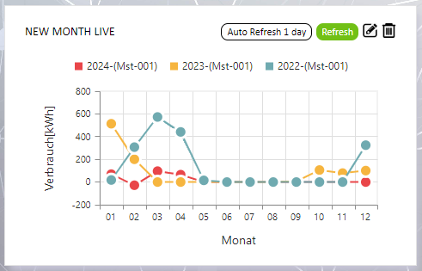
Save tiles structure tab (Struktur speichern)
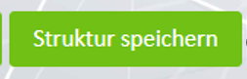
This tab allows users to set the priority and arrangement of tiles structure using a drag-and-drop interface. Users can reorder the tiles based on their preferences or importance, and the dashboard will reflect this order during display.
Messstellen, Zeitvergleich, and Kennzahlen Tabs
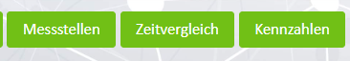
The Messstellen, Zeitvergleich, and Kennzahlen tabs are used to display saved graph information created by the user. Each tab represents a different type of analytical view. The saved graphs are listed in a table format for easy browsing. Each entry includes details like the graph name, creation date, and associated filters or parameters.
When the user clicks on a specific graph, it opens in a new tab, where the data is rendered in graphical format (charts or plots) for detailed analysis.
Messstellen (Measuring Points) Tab: Messstellen tab displays a list of saved graphs related to specific measuring points (Messstellen) in a data table format. Each row in the table represents a graph saved by the user, showing details such as (Graph ID, Title, Description, Type, Delete Action). User can delete a saved graph by clicking the delete icon in the Action column. This permanently removes the selected graph from the saved list.
Users can click on any row to open the corresponding graph in a new tab, where the data is shown in a graphical representation for detailed analysis.
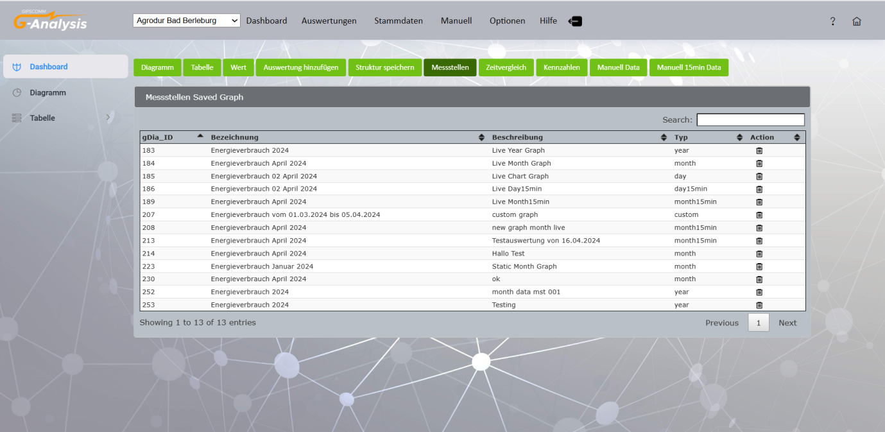
Zeitvergleich (Time Comparison) Tab: Zeitvergleich tab displays graphs that compare data across different time periods. Each row in the table represents a graph saved by the user, showing details such as (Graph ID, Title, Description, Type, Delete Action). User can delete a saved graph by clicking the delete icon in the Action column. This permanently removes the selected graph from the saved list.
Users can click on any row to open the corresponding graph in a new tab, where the data is shown in a graphical representation for detailed analysis.
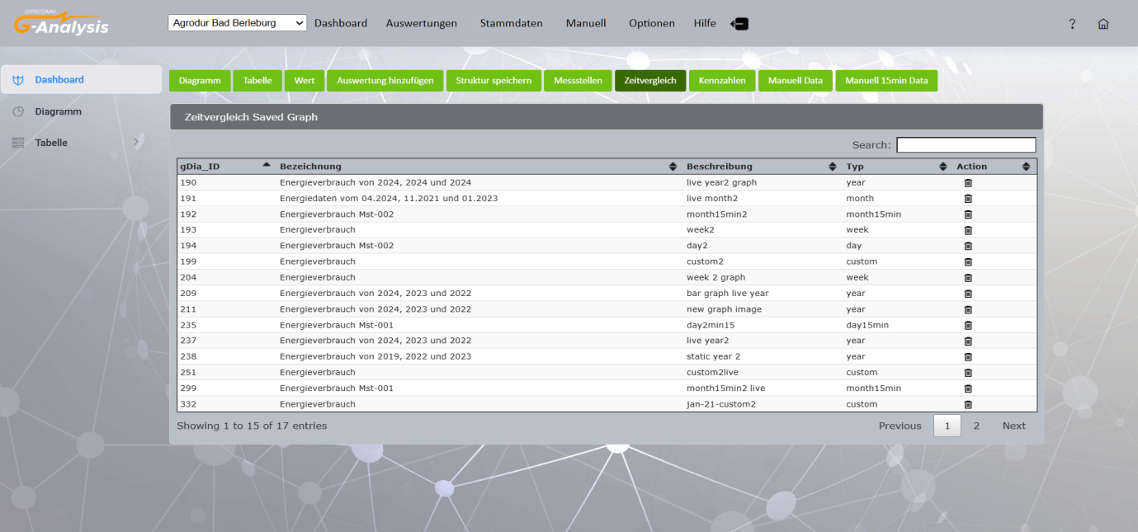
Kennzahlen (Key Figures) Tab: Focuses on graphs representing key performance indicators or summarized metrics. Each row in the table represents a graph saved by the user, showing details such as (Graph ID, Title, Description, Type, Delete Action). User can delete a saved graph by clicking the delete icon in the Action column. This permanently removes the selected graph from the saved list.
Users can click on any row to open the corresponding graph in a new tab, where the data is shown in a graphical representation for detailed analysis.
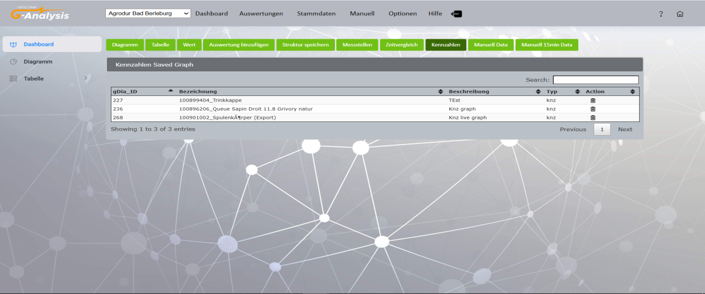
Manuell Data Tab: Click on the “Manuell Data” tab to view your imported manual data. The data can be filtered based on day, hour, month, and year tabs, allowing users to easily analyses and review their entries over different time periods.
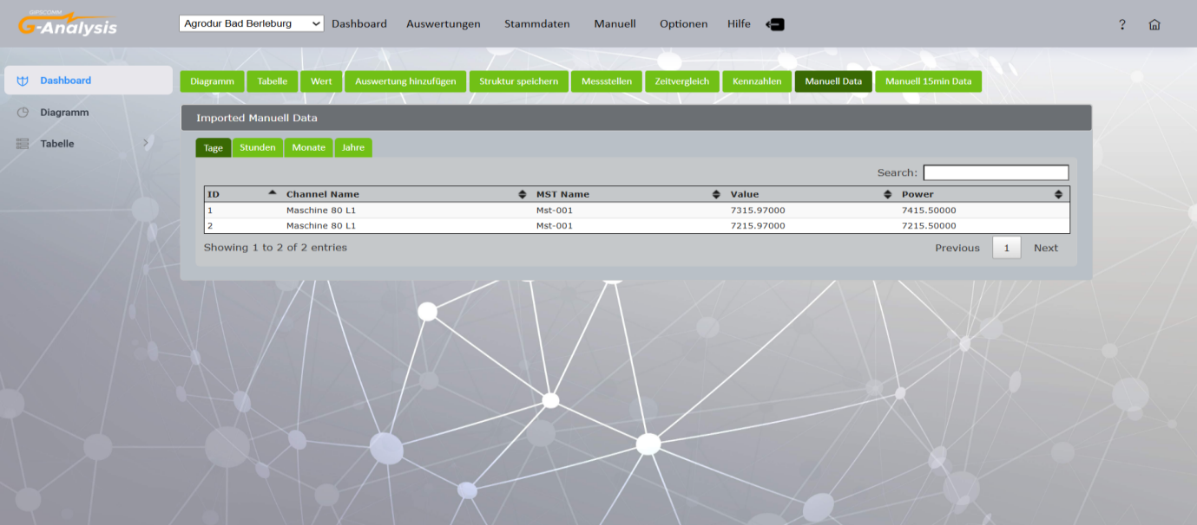
Manuell 15min Data Tab: Click on the “Manuell 15min Data” tab to view your imported manual data in 15-minute intervals. This tab displays detailed entries uploaded by the user, allowing for precise time-based data analysis.
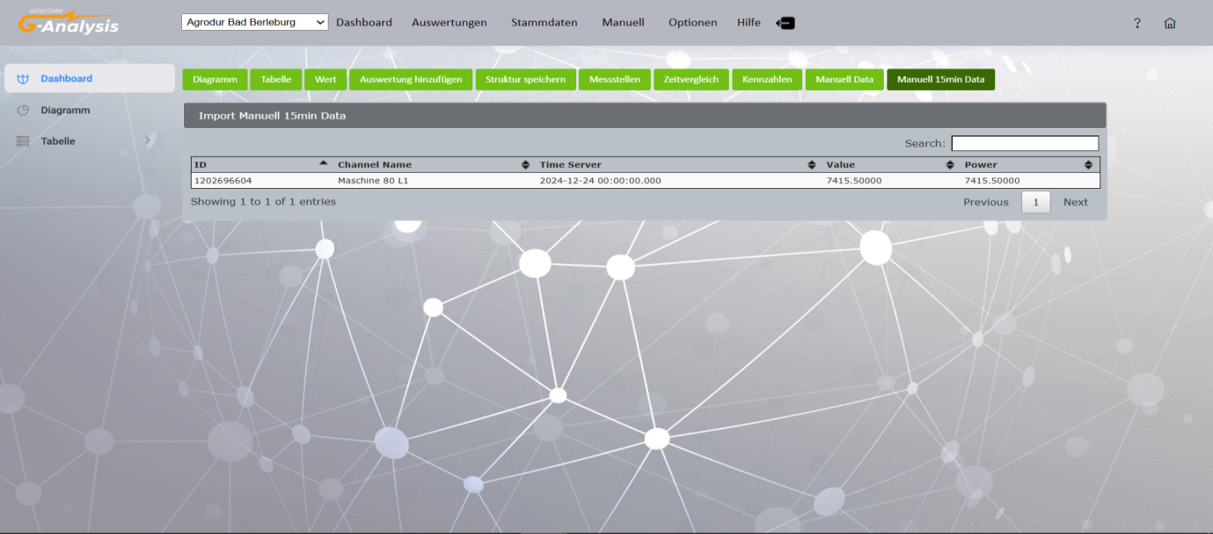
Third-Party Providers and Software Libraries
Core UI & Data Visualization
- Syncfusion: Powers professional-grade UI components, including advanced reporting tools, interactive data grids, and complex charting modules.
- SpreadJS: Provides high-performance, Excel-like spreadsheet functionality directly within the browser, enabling complex data entry and calculation.
- Chart.js: Utilized for a wide range of dynamic data plotting and graphical representations.
- FullCalendar: Offers an interactive management interface for tracking and organizing calendar-based events.
Frontend Frameworks & Interactivity
- Bootstrap (v4/v5): The foundational CSS framework ensuring a responsive, mobile-first design and consistent layout.
- jQuery & jQuery UI: Standard JavaScript libraries employed for efficient DOM manipulation and the implementation of interactive widgets.
- DataTables: Enhances tabular data with advanced features such as FixedHeaders, ColReorder, and export buttons.
- Select2: Provides intuitive, searchable, and multi-selection dropdown menus.
- MathQuill: An integrated mathematical formula editor for specialized data input.
System Utilities & Notifications
- Moment.js: The primary library for precise date and time parsing, validation, and formatting.
- Toastr: Delivers subtle, non-blocking notification alerts for a smooth user experience.
- SweetAlert2: Powers responsive and aesthetically pleasing popup dialogs and confirmation modals.
- Pace.js: Implements automatic progress bars to monitor page load performance.
- PDFMake & JSZip: Specialized libraries for generating on-the-fly PDF exports and managing compressed ZIP file formats.
NOTE: To access source code files:
git clone https://github.com/Gipscomm-Energy-G-Analysis/G-analysis-public/tree/release/2.0

